

Name : Yogesh Dinesh Joshi
Sap id : 590025632
Batch : 34
Teacher : Sugandha Sharma

Python Programming : Experiment 9

Objective 1: Create a class of student (name, sap id, marks [phy,chem,maths] ) . Create 3 objects by taking inputs from the user and display details of all students.
Code : 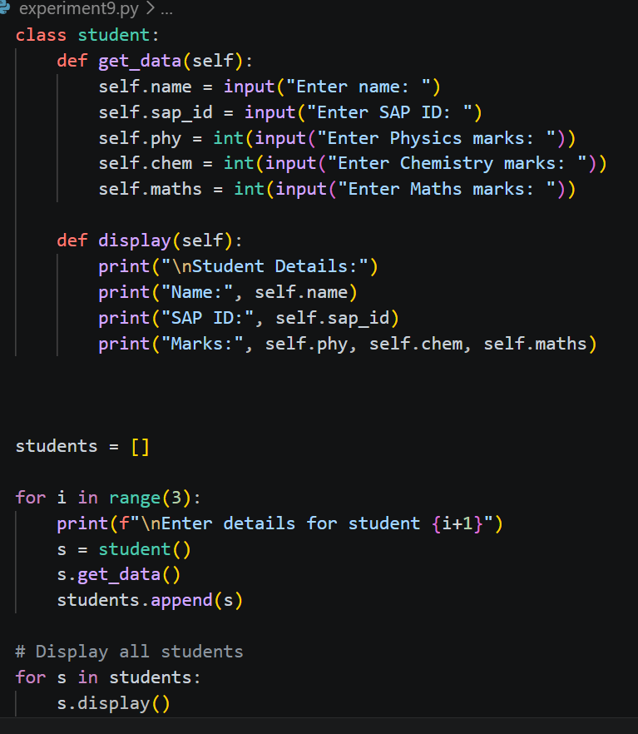
Output : 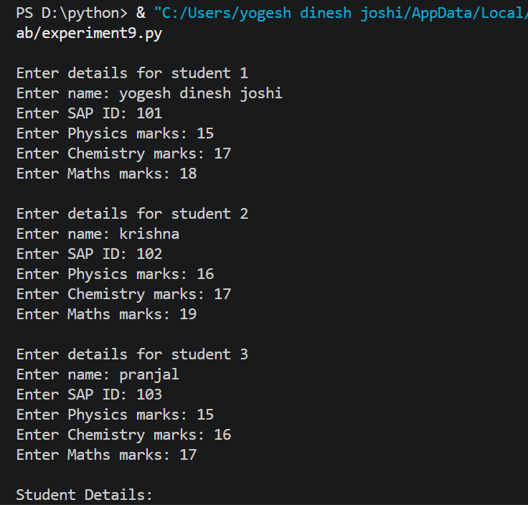
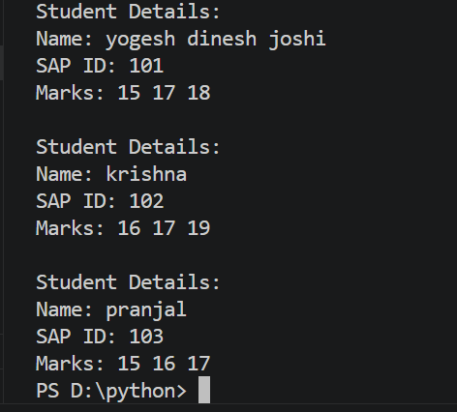
Objective 2: Add constructor in the above class to initialize student details of n students and implement following methods:
- Display() student details
- Find Marks_percentage() of each student
- Display result() [Note: if marks in each subject >40% than Pass else Fail]
- Write a Function to find average of the class.
Code: 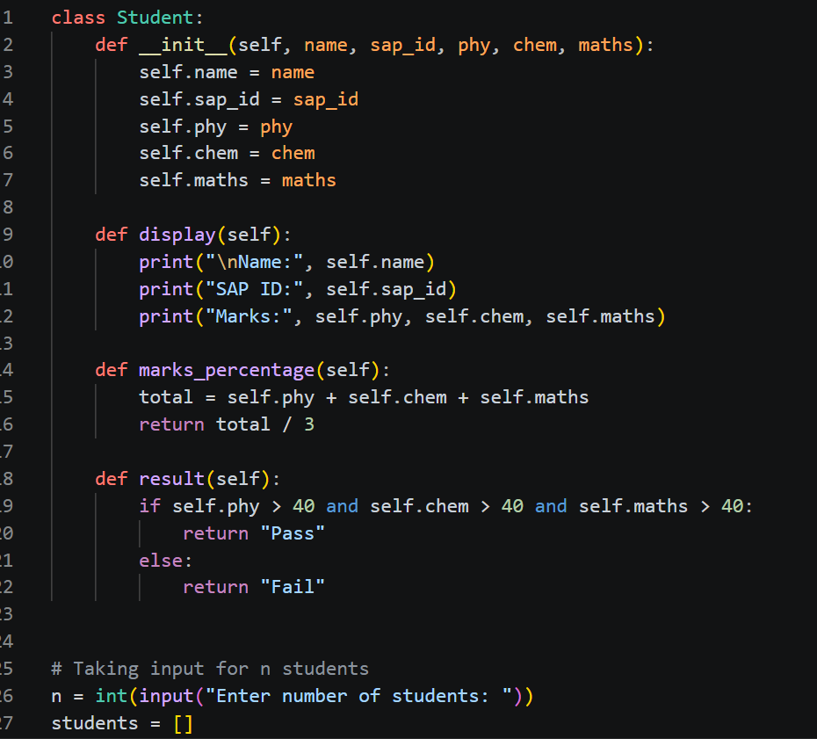
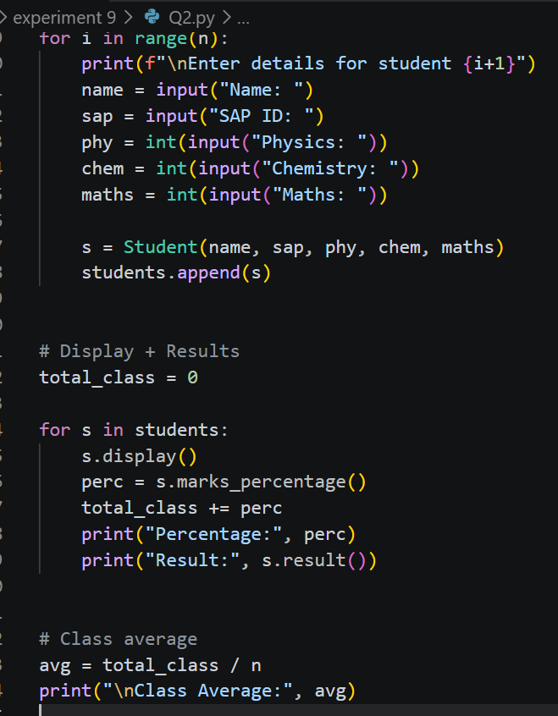
Output : 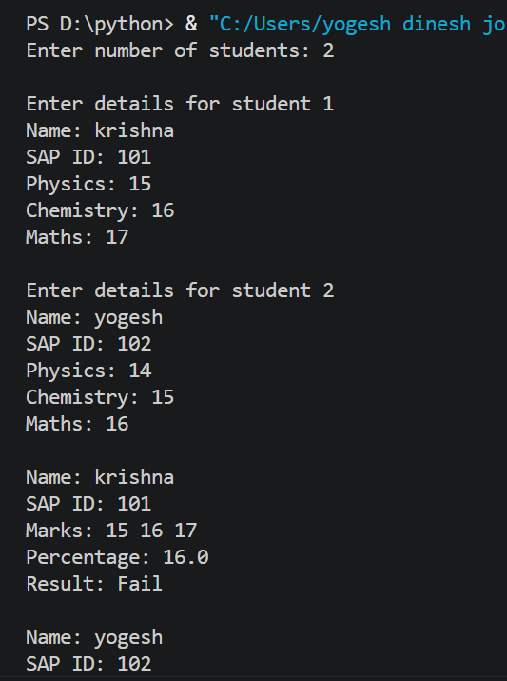
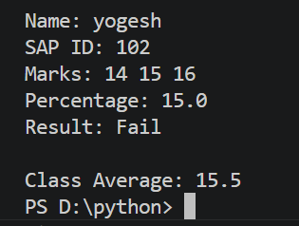
Objective 3: Create programs to implement different types of inheritances.
Code : 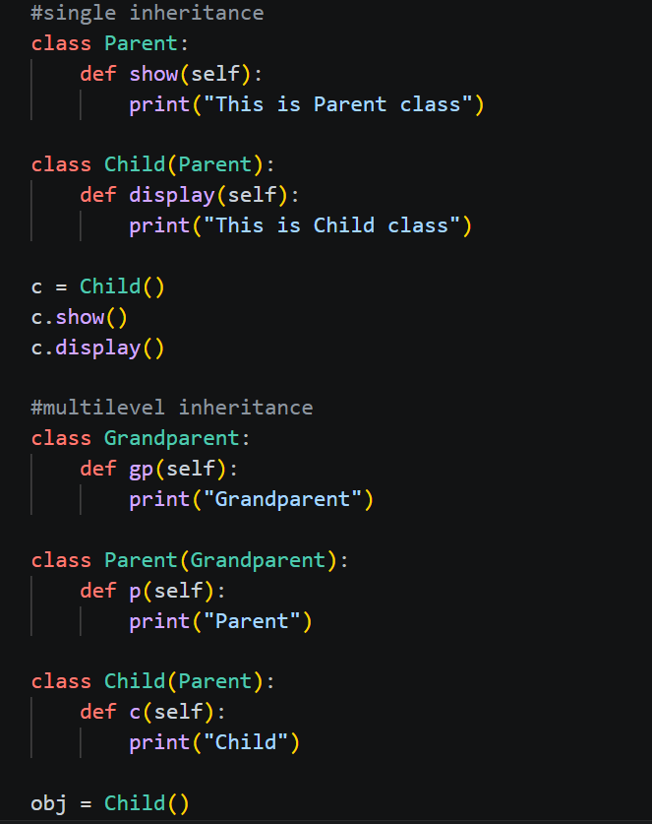
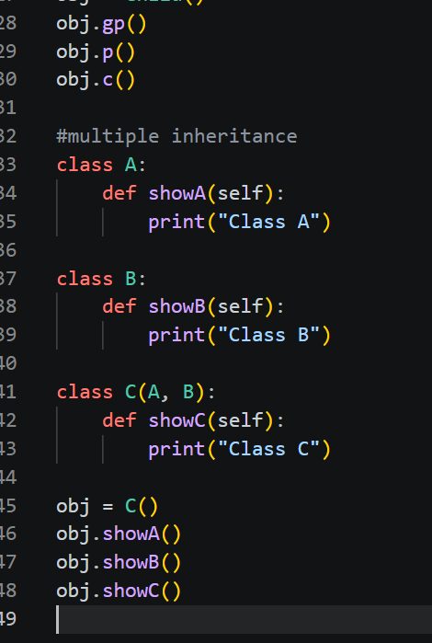
Output : 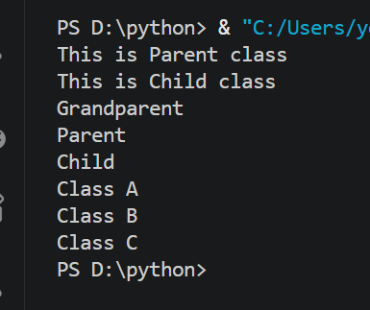
Objective 4: Create a class to implement method Overriding.
Code : 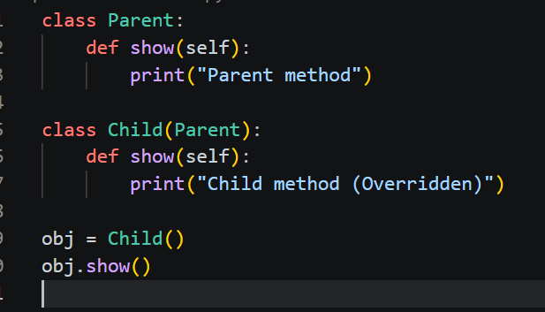
Output : 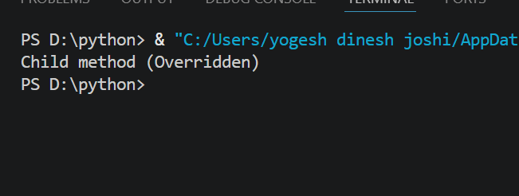
Objective 5 : . Create a class for operator overloading which adds two Point Objects where Point has x & y values
e.g. if
P1(x=10,y=20)
P2(x=12,y=15)
P3=P1+P2 => P3(x=22,y=35)

Code : 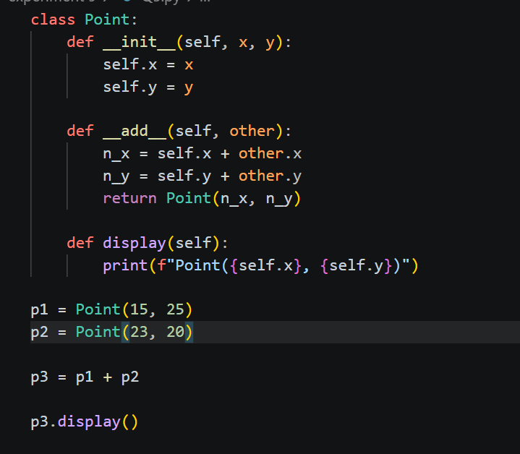
Output : 